Who made the crunchiest cookies? Whose were the most delicious?
Are your cookies smaller than mine?
Are my cookies prettier than yours?
Will Laila’s cookies be chewier than Capois’?

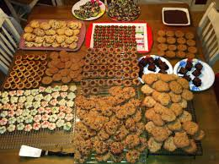
Find out at the
Superlative Cookie Picnic!
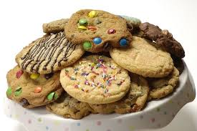
Are you a terrible cook?
Don’t stress! Ugly and icky are fun to talk about if not to eat!
Please bring a picnic blanket, towel or chair and the cookie of your
choice as we use our comparatives and superlatives
to discuss our homemade and store-bought cookies.

